Processor architecture

practical 2

Division/Batch: B/B1  
Branch: Computer Engineering

|  |  |  |  |  |
| --- | --- | --- | --- | --- |
| **SAP ID** | **Name of Student** | **Date of Experiment** | **Date of Submission** | **Remarks** |
| 60004200107 | Kartik Jolapara | 27/9/22 | 3/10/22 |  |

# Aim

To study and implement restoring and non-restoring division algorithm.

Restoring Division

Theory

A division algorithm is an algorithm which, given two integers N and D, computes their quotient and/or remainder, the result of Euclidean division. Division algorithms fall into two main categories: slow division and fast division. Slow division algorithms produce one digit of the final quotient per iteration. Examples of slow division include restoring, non-performing restoring, non-restoring, and SRT division. Fast division methods start with a close approximation to the final quotient and produce twice as many digits of the final quotient on each iteration. Newton–Raphson and Goldschmidt algorithms fall into this category.

Restoring Division Algorithm is used to divide two unsigned integers. This algorithm is used in Computer Organization and Architecture. This algorithm is called restoring because it restores the value of Accumulator(A) after each or some iterations. There is one more type i.e., Non-Restoring Division Algorithm in which value of A is not restored.

Here, register Q contain quotient and register A contain remainder. Here, n-bit dividend is loaded in Q and divisor is loaded in M. Value of Register is initially kept 0 and this is the register whose value is restored during iteration due to which it is named Restoring.

# Algorithm

Restoring division operates on fixed-point fractional numbers and depends on the assumption 0 < D < N. The basic algorithm for binary (radix 2) restoring division is:

R := N

D := D << n *-- R and D need twice the word width of N and Q*

**for** i := n − 1 .. 0 **do** *-- For example 31..0 for 32 bits*

R := 2 * R − D *-- Trial subtraction from shifted value*

**if** R ≥ 0 **then**

q(i) := 1 *-- Result-bit 1*

**else**

q(i) := 0 *-- Result-bit 0*

R := R + D *-- New partial remainder is (restored) shifted value*

**end**

**end**

In simpler terms, let the dividend be Q and the divisor be M and the accumulator A = 0.

Therefore:

1. At each step, left shift the dividend by 1 position.
2. Subtract the divisor from A (A – M).
3. If the result is positive, then the step is said to be successful. In this case, the quotient bit will be “1” and the restoration is not required.
4. If the result is negative, then the step is said to be unsuccessful. In this case, the quotient bit will be “0” and restoration is required.
5. Repeat the above steps for all the bits of the dividend.

# Example

**Problem: 13/4 M=0100 Q=1101 -M=1100 N=4**

|  |  |  |  |  |
| --- | --- | --- | --- | --- |
| **N** | **M** | **A** | **Q** | **Operation** |
| 4 | 0100 | 0000 | 1101 | Initialization |
|  | 0100 | 0001 | 101- | LS, N=N-1 |
|  | 0100 | 1101 | 101- | A=A-B |
|  | 0100 | 0001 | 1010 | A=A+B |
| 3 | 0100 | 0001 | 1010 |  |
|  | 0100 | 0011 | 010- | LS, N=N-1 |
|  | 0100 | 1111 | 010- | A=A-B |
|  | 0100 | 0011 | 0100 | A=A+B |
| 2 | 0100 | 0011 | 0100 |  |
|  | 0100 | 0110 | 100- | LS, N=N-1 |
|  | 0100 | 0010 | 100- | A=A-B |
|  | 0100 | 0010 | 1001 |  |
| 1 | 0100 | 0010 | 1001 |  |
|  | 0100 | 0101 | 001- | LS, N=N-1 |
|  | 0100 | 0001 | 001- | A=A-B |
|  | 0100 | 0001 | 0011 | Termination |

**Result: Quotient: 0011 Remainder: 0001**

# Flowchart

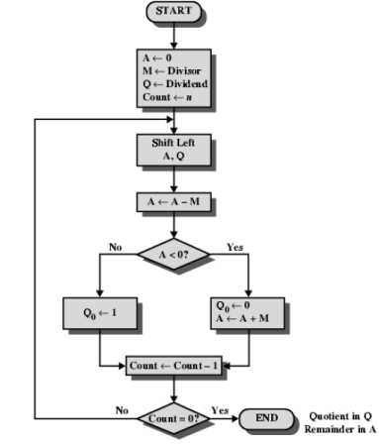

# Code

// Non-restoring division

#include <bits/stdc++.h>

using namespace std;

vector<bool> oneSComplement(vector*<bool> num)*

{

    for (int i = 0; i < *num*.size(); i++)

    {

*num*[i] = !*num*[i];

    }

    return *num*;

}

vector<bool> twoSComplement(vector<bool> *num*)

{

*num* = oneSComplement(*num*);

    if (*num*[*num*.size() - 1])

    {

*num*[*num*.size() - 1] = 0;

*num*[*num*.size() - 2] = 1;

    }

    else

    {

*num*[*num*.size() - 1] = 1;

    }

    return *num*;

}

vector<bool> binaryAddition(vector<bool> *a*, vector<bool> *b*, int *n*)

{

    vector<bool> ans(*n*);

    bool carry = 0;

    for (int i = *n* - 1; i >= 0; i--)

    {

        if (*a*[i] == 1 && *b*[i] == 1 && carry)

        {

            ans[i] = 1;

            carry = 1;

        }

        else if ((*a*[i] == 1 && *b*[i] == 1) || (((*a*[i] == 1) || (*b*[i] == 1)) && carry))

        {

            ans[i] = 0;

            carry = 1;

        }

        else

        {

            ans[i] = *a*[i] + *b*[i] + carry;

            carry = 0;

        }

    }

    return ans;

}

// Returns the right most shifted value from the q

bool arithmeticRightShift(vector<bool> &*a*, vector<bool> &*q*)

{

    bool kachra = *q*[*q*.size() - 1], prev = *a*[0], temp;

    for (int i = 1; i < *a*.size(); i++)

    {

        temp = *a*[i];

*a*[i] = prev;

        prev = temp;

    }

    temp = *q*[0];

*q*[0] = prev;

    prev = temp;

    for (int i = 1; i < *q*.size(); i++)

    {

        temp = *q*[i];

*q*[i] = prev;

        prev = temp;

    }

    return kachra;

}

// Left Shifts the 2 numbers :)

void arithmeticLeftShift(vector<bool> &*a*, vector<bool> &*q*)

{

    bool kachra = *q*[*q*.size() - 1], prev = *a*[0], temp;

    for (int i = 0; i < *a*.size() - 1; i++)

    {

*a*[i] = *a*[i + 1];

    }

*a*[*a*.size() - 1] = *q*[0];

    for (int i = 0; i < *q*.size() - 1; i++)

    {

*q*[i] = *q*[i + 1];

    }

}

int main()

{

    // Taking the input in string so that we don't need to ask for the size of the number

*string* qtemp, mtemp;

    // Then storing the number in a vector(Array) for easy access

    vector<bool> q, m, a, negM;

    bool qNeg = 0;

    // We'll be taking the input in binary format only

    cout << "Enter m(divisor): ";

    cin >> mtemp;

    cout << "Enter q(dividend): ";

    cin >> qtemp;

    // Counter

    int n;

    // Assigning the counter with the max value

    // if (mtemp.length() > qtemp.length())

    //     n = mtemp.length();

    // else

    //     n = qtemp.length();

    n = qtemp.length();

    int count = n;

    // Assigning the Accumulator with 0's

    for (int i = 0; i < n + 1; i++)

    {

        a.push_back(0);

    }

    int mtempNum = (n + 1) - mtemp.length();

    while (mtempNum > 0)

    {

        m.push_back(0);

        mtempNum--;

    }

    // Converting the string into vector(array)

    for (int i = 0; i < qtemp.length(); i++)

    {

        if (qtemp[i] == '1')

            q.push_back(1);

        else

            q.push_back(0);

    }

    for (int i = 0; i < mtemp.length(); i++)

    {

        if (mtemp[i] == '1')

            m.push_back(1);

        else

            m.push_back(0);

    }

    // Calculating the -M

    negM = twoSComplement(m);

    vector<bool> ans = binaryAddition(m, q, n);

    cout << "\nA\tQ\tn\tAction\n\n";

    while (count)

    {

        // --- Init Printing format ---

        for (auto x : a)

            cout << x;

        cout << "\t";

        for (auto x : q)

            cout << x;

        cout << "\t" << count << "\t"

             << "Init"

             << "\n";

        // --- Init Printing format ---

        arithmeticLeftShift(a, q);

        // --- Shift LEFT Printing format ---

        for (auto x : a)

            cout << x;

        cout << "\t";

        int tempCount = 0;

        for (auto x : q)

        {

            tempCount++;

            cout << ((tempCount == n) ? "_" : to_string(x));

        }

        cout << "\t" << count << "\t"

             << "Shift LEFT"

             << "\n";

        // --- Shift LEFT Printing format ---

        a = binaryAddition(a, negM, n + 1);

        // --- A-M Printing format ---

        for (auto x : a)

            cout << x;

        cout << "\t";

        tempCount = 0;

        for (auto x : q)

        {

            tempCount++;

            cout << ((tempCount == n) ? "_" : to_string(x));

        }

        cout << "\t" << count << "\t"

             << "A-M"

             << "\n";

        // --- A-M Printing format ---

        // a[0] = 1 means the number is -ve

        if (a[0])

        {

            q[q.size() - 1] = 0;

            a = binaryAddition(a, m, n + 1);

            // --- Q0<-0, A-M Printing format ---

            for (auto x : a)

                cout << x;

            cout << "\t";

            // int tempCount = 0;

            for (auto x : q)

            {

                // tempCount++;

                // cout << ((tempCount == n) ? "_" : to_string(x));

                cout << x;

            }

            cout << "\t" << count << "\t"

                 << "Q0<-0, A-M"

                 << "\n";

            // --- Q0<-0, A-M Printing format ---

        }

        else

        {

            q[q.size() - 1] = 1;

            // --- Q0<-1 Printing format ---

            for (auto x : a)

                cout << x;

            cout << "\t";

            // int tempCount = 0;

            for (auto x : q)

            {

                // tempCount++;

                // cout << ((tempCount == n) ? "_" : to_string(x));

                cout << x;

            }

            cout << "\t" << count << "\t"

                 << "Q0<-1"

                 << "\n";

            // --- Q0<-1 Printing format ---

        }

        cout << "\n";

        count--;

    };

    cout << "Quotient: ";

    for (auto x : q)

        cout << x;

    cout << "\n";

    cout << "Remainder: ";

    for (auto x : a)

        cout << x;

    return 0;

}

# Output

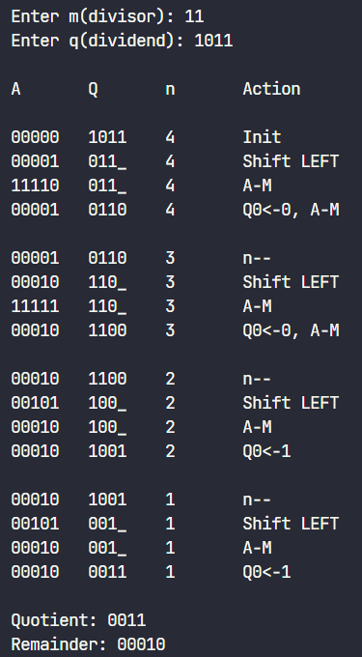

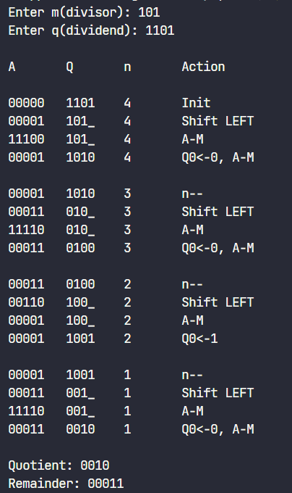

Non-Restoring Division

Theory

Non-Restoring Division Algorithm is used to divide two unsigned integers. This algorithm is used in Computer Organization and Architecture The algorithm is more complex but has the advantage when implemented in hardware that there is only one decision and addition/subtraction per quotient bit; there is no restoring step after the subtraction, which potentially cuts down the numbers of operations by up to half and lets it be executed faster.

Here, register Q contain quotient and register A contain remainder. Here, n-bit dividend is loaded in Q and divisor is loaded in M. Value of Register is initially kept 0. Non-restoring division uses the digit set {−1, 1} for the quotient digits instead of {0, 1}.

Algorithm

The basic algorithm for binary (radix 2) non-restoring division of non-negative numbers is:

R := N

D := D << n *-- R and D need twice the word width of N and Q*

**for** i = n − 1 .. 0 **do** *-- for example 31..0 for 32 bits*

**if** R >= 0 **then**

q[i] := +1

R := 2 * R − D

**else**

q[i] := −1

R := 2 * R + D

**end** **if**

**end**

In simpler terms, let the dividend be Q and the divisor be M and the accumulator A = 0.

Therefore:

1. First the registers are initialized with corresponding values
2. Check the sign bit of register A
3. If it is 1 shift left content of AQ and perform A = A+M, otherwise shift left AQ and perform A = A-M
4. If sign bit of register A is 1 Q[0] become 0 otherwise Q[0] become 1
5. Decrements value of N by 1, If N is not equal to zero go to Step 2
6. If sign bit of A is 1 then perform A = A+M

Example

**Problem: 13/4 M=0100 Q=1101 -M=1100 N=4**

|  |  |  |  |  |
| --- | --- | --- | --- | --- |
| **N** | **M** | **A** | **Q** | **Operation** |
| 4 | 0100 | 0000 | 1101 | Initialization |
|  | 0100 | 0001 | 101- | LS, N=N-1 |
|  | 0100 | 1101 | 101- | A=A-M |
|  | 0100 | 1101 | 1010 |  |
| 3 | 0100 | 1101 | 1010 |  |
|  | 0100 | 1011 | 010- | LS, N=N-1 |
|  | 0100 | 1111 | 010- | A=A+B |
|  | 0100 | 1111 | 0100 |  |
| 2 | 0100 | 1111 | 0100 |  |
|  | 0100 | 1110 | 100- | LS, N=N-1 |
|  | 0100 | 0010 | 100- | A=A+B |
|  | 0100 | 0010 | 1001 |  |
| 1 | 0100 | 0010 | 1001 |  |
|  | 0100 | 0101 | 001- | LS, N=N-1 |
|  | 0100 | 0001 | 001- | A=A-B |
|  | 0100 | 0001 | 0011 | Termination |

**Result: Quotient: 0011 Remainder: 0001**

Flowchart

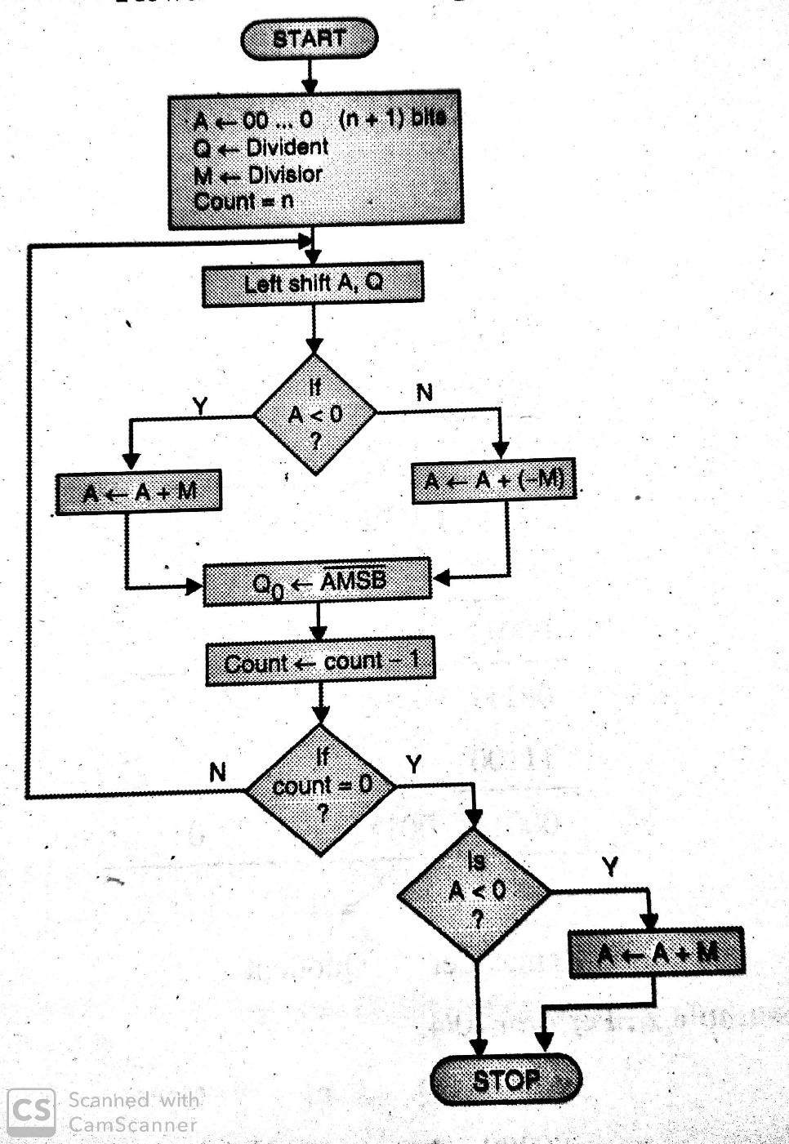

Code

// Non-restoring division

/*

Write up

1. Aim

FLowchart

2. Theory

3. Code (text)

4. Output

5. Conclusion

*/

#include <bits/stdc++.h>

using namespace std;

vector<bool> oneSComplement(vector<bool> *num*)

{

    for (int i = 0; i < *num*.size(); i++)

    {

*num*[i] = !*num*[i];

    }

    return *num*;

}

vector<bool> twoSComplement(vector<bool> *num*)

{

*num* = oneSComplement(*num*);

    if (*num*[*num*.size() - 1])

    {

*num*[*num*.size() - 1] = 0;

*num*[*num*.size() - 2] = 1;

    }

    else

    {

*num*[*num*.size() - 1] = 1;

    }

    return *num*;

}

vector<bool> binaryAddition(vector<bool> *a*, vector<bool> *b*, int *n*)

{

    vector<bool> ans(*n*);

    bool carry = 0;

    for (int i = *n* - 1; i >= 0; i--)

    {

        if (*a*[i] == 1 && *b*[i] == 1 && carry)

        {

            ans[i] = 1;

            carry = 1;

        }

        else if ((*a*[i] == 1 && *b*[i] == 1) || (((*a*[i] == 1) || (*b*[i] == 1)) && carry))

        {

            ans[i] = 0;

            carry = 1;

        }

        else

        {

            ans[i] = *a*[i] + *b*[i] + carry;

            carry = 0;

        }

    }

    return ans;

}

// Returns the right most shifted value from the q

bool arithmeticRightShift(vector<bool> &*a*, vector<bool> &*q*)

{

    bool kachra = *q*[*q*.size() - 1], prev = *a*[0], temp;

    for (int i = 1; i < *a*.size(); i++)

    {

        temp = *a*[i];

*a*[i] = prev;

        prev = temp;

    }

    temp = *q*[0];

*q*[0] = prev;

    prev = temp;

    for (int i = 1; i < *q*.size(); i++)

    {

        temp = *q*[i];

*q*[i] = prev;

        prev = temp;

    }

    return kachra;

}

// Left Shifts the 2 numbers :)

void arithmeticLeftShift(vector<bool> &*a*, vector<bool> &*q*)

{

    bool kachra = *q*[*q*.size() - 1], prev = *a*[0], temp;

    for (int i = 0; i < *a*.size() - 1; i++)

    {

*a*[i] = *a*[i + 1];

    }

*a*[*a*.size() - 1] = *q*[0];

    for (int i = 0; i < *q*.size() - 1; i++)

    {

*q*[i] = *q*[i + 1];

    }

}

int main()

{

    // Taking the input in string so that we don't need to ask for the size of the number

*string* qtemp, mtemp;

    // Then storing the number in a vector(Array) for easy access

    vector<bool> q, m, a, negM;

    bool qNeg = 0;

    // We'll be taking the input in binary format only

    cout << "Enter m: ";

    cin >> mtemp;

    cout << "Enter q: ";

    cin >> qtemp;

    // Counter

    int n;

    // Assigning the counter with the max value

    // if (mtemp.length() > qtemp.length())

    //     n = mtemp.length();

    // else

    //     n = qtemp.length();

    n = qtemp.length();

    int count = n;

    // Assigning the Accumulator with 0's

    for (int i = 0; i < n + 1; i++)

    {

        a.push_back(0);

    }

    int mtempNum = (n + 1) - mtemp.length();

    while (mtempNum > 0)

    {

        m.push_back(0);

        mtempNum--;

    }

    // Converting the string into vector(array)

    for (int i = 0; i < qtemp.length(); i++)

    {

        if (qtemp[i] == '1')

            q.push_back(1);

        else

            q.push_back(0);

    }

    for (int i = 0; i < mtemp.length(); i++)

    {

        if (mtemp[i] == '1')

            m.push_back(1);

        else

            m.push_back(0);

    }

    // Calculating the -M

    negM = twoSComplement(m);

    vector<bool> ans = binaryAddition(m, q, n);

    cout << "\nA\tQ\tn\tAction\n\n";

    while (count)

    {

        // --- Init Printing format ---

        for (auto x : a)

            cout << x;

        cout << "\t";

        for (auto x : q)

            cout << x;

        cout << "\t" << count << "\t"

             << (count == n ? "Init" : "n--")

             << "\n";

        // --- Init Printing format ---

        arithmeticLeftShift(a, q);

        // --- Shift LEFT Printing format ---

        for (auto x : a)

            cout << x;

        cout << "\t";

        int tempCount = 0;

        for (auto x : q)

        {

            tempCount++;

            cout << ((tempCount == n) ? "_" : to_string(x));

        }

        cout << "\t" << count << "\t"

             << "Shift LEFT"

             << "\n";

        // --- Shift LEFT Printing format ---

        // a[0] = 1 means the number is -ve

        if (a[0])

        {

            a = binaryAddition(a, m, n + 1);

            // --- A+M Printing format ---

            for (auto x : a)

                cout << x;

            cout << "\t";

            tempCount = 0;

            for (auto x : q)

            {

                tempCount++;

                cout << ((tempCount == n) ? "_" : to_string(x));

            }

            cout << "\t" << count << "\t"

                 << "A+M"

                 << "\n";

            // --- A+M Printing format ---

        }

        else

        {

            a = binaryAddition(a, negM, n + 1);

            // --- A-M Printing format ---

            for (auto x : a)

                cout << x;

            cout << "\t";

            tempCount = 0;

            for (auto x : q)

            {

                tempCount++;

                cout << ((tempCount == n) ? "_" : to_string(x));

            }

            cout << "\t" << count << "\t"

                 << "A-M"

                 << "\n";

            // --- A-M Printing format ---

        }

        q[q.size() - 1] = !a[0];

        // --- Q0<-!A(MSB) Printing format ---

        for (auto x : a)

            cout << x;

        cout << "\t";

        tempCount = 0;

        for (auto x : q)

        {

            tempCount++;

            cout << x;

        }

        cout << "\t" << count << "\t"

             << "Q0<-!A(MSB)"

             << "\n\n";

        // --- Q0<-!A(MSB) Printing format ---

        count--;

    };

    // a[0] = 1 means the number is -ve

    if (a[0])

    {

        a = binaryAddition(a, m, n + 1);

        // --- A<0, A+M Printing format ---

        for (auto x : a)

            cout << x;

        cout << "\t";

        int tempCount = 0;

        for (auto x : q)

        {

            tempCount++;

            cout << x;

        }

        cout << "\t" << count << "\t"

             << "A<0, A+M"

             << "\n\n";

        // --- A<0, A+M Printing format ---

    }

    cout << "Quotient: ";

    for (auto x : q)

        cout << x;

    cout << "\n";

    cout << "Remainder: ";

    for (auto x : a)

        cout << x;

    return 0;

}

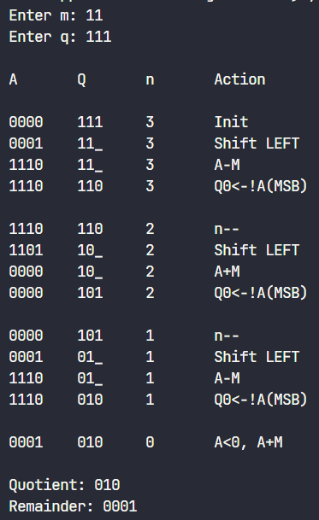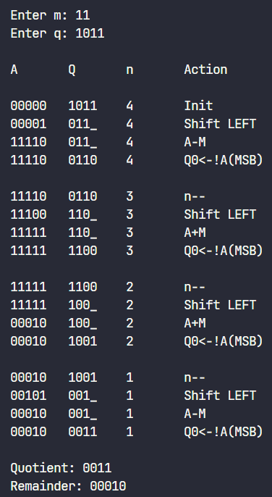Output

# Conclusion

The restorative division algorithm is an efficient way to perform binary division compared to traditional subtractive based algorithms by using the faster processed bit shift commands in the CPU registers. The algorithm is simple enough to be implemented in hardware in equipment like Arithmometers while also generalising to complex modern day systems. The algorithm serves as a good example in showing that considering lower-level system dependencies and physical limitations can be used to optimize algorithms.

The non-restorative division algorithm is an efficient way to perform binary division compared to traditional subtractive based algorithms by using the faster processed bit shift commands in the CPU registers. The algorithm serves as a good example in showing that considering lower-level system dependencies and physical limitations can be used to optimize algorithms. Non-restorative algorithm is more efficient than restorative algorithm as it uses simpler commands in terms of addition and subtraction however it is slower than other algorithms.